CIS3203: Artificial Intelligence
Professor: Dr. Wang
Final report
November 8, 2014

Driverless Car

Driverless car is the car which is also known as self-driving car, autonomous car. It can travel between destinations without a human operator using those sensors that are attached on the car. Whether the driver is present inside the car or not, it is possible for the owner of the car to control the car and accelerator and brake automatically operated.
Since the idea of "driverless car" is deemed innovative, a lot of companies have tried to make driverless car as well to put similar items in the market. Among those companies, Google has actively conducted a research about driverless car. Most people might be thinking this could be used in the distant future, but surprisingly, this is already developed a lot. Driverless car is in its final stages of completion. For example, by test-driving, self-driving Google cars passed 300,000 miles with no accidents, and Nevada has issued the first ever U.S. license plates for a driverless car being developed by Google.

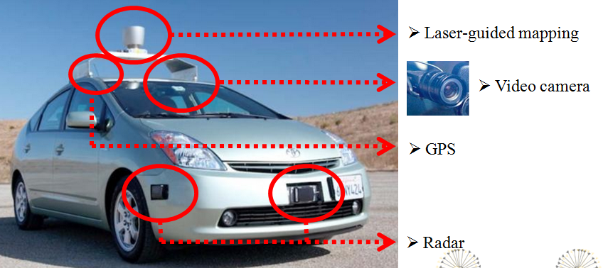

Now, Let's talk about the principle of Google's self-driving car. As you can see above, there are a lot of sensors in the car. At first, on the top of the car, there are Laser-guided mapping which uses the LASER light to detect obstacles within 200 feet distance. It also has a video camera which is used to detect traffic signals and other cars. In addition, there are radar sensors that help determine the positions of distant objects. The car can go to the right direction because of GPS. Artificial Intelligence in driverless car collects those information, and converts to three dimension map. Through this map, AI would know the surround condition of the car more accurately. With those of the information like distance with the car, destination, traffic lights, road sign, AI should make a best decision to go intended destination without the human intervention
If I introduce one of the AI algorithm that are used in driverless car, there is collision avoidance algorithm. That explains how driverless car can avoid those obstacles. The basic idea behind collision avoidance is that the closest obstacle ahead of the character is considered to be the most threatening and it is selected for evaluation. As a result the character is able to dodge all obstacles in the area, transitioning from one to another gracefully.
Through searching for those information, I think there are some benefits of self-driving cars. I have some statistics showing that there exist more than 30,000 fatal crashes each year in the United States. And most part of those traffic fatalities are drunk driving, speeding, distraction which are caused by human driver's faults. However, if you let robots take the wheel, most of the accidents caused by human's mistakes would be greatly reduced. In addition, it allows people who cannot drive like disabled people, younger people to use a car. You can also read the book or newspaper, and do your homework while AI's driving. At last, we no longer need unskilled, clumsy human drivers, and self-driving cars will be able to bunch close together at steadier speeds. That boosts fuel efficiency.
I think there also are some limits of driverless car. If there are some problems in program or AI makes a wrong decision, that would lead to huge car accidents. Furthermore, if driverless car hits the human on the road, it is hard to judge whose fault it is. It also has some serious security issues. Personal information such as home address, moving routes are stored in AI's computer. If someone can access the other one's computer, it could result serious social issues. For example, If terrorist can hack the program and take control of the car, this can be used in terrorist attack.
Here is my solution to solve the technical errors in the driverless car. To use airplane which is considered the most state-of-the-art technology as an example, there are two ground devises that helps an airplane in landing at airport. Using those lights, airplane could be landing precisely down the runway. Like this, a lot of devices should be installed on the road to help driverless car's AI system. For example, by installing a variety of devices on the road, car can be charged toll automatically by sensors without slow down the car. Also by using autotracking camera, people can monitor any unexpected accidents or situations and pass the information to Ai. If we can monitor the road, we can give information about the cars and the roads to AI. and Ai will use this information to make a better decision.
Researching on this project, I realized that the concepts of artificial intelligence has been used in different kind of fields. It was a good opportunity for me to study more about this area.

I can find those materials from here:
http://www.statisticbrain.com/car-crash-fatality-statistics-2/
http://guardianlv.com/2014/05/the-benefits-of-google-driverless-cars/
http://gamedevelopment.tutsplus.com/tutorials/understanding-steering-behaviors-collision-avoidance--gamedev-7777
http://en.wikipedia.org/wiki/Google_driverless_car
http://www.vox.com/2014/5/28/5756736/the-case-for-self-driving-cars

