Fuzzy Logic
By Sang Cun

What is fuzzy logic? Here is a definition about fuzzy logic: fuzzy logic is a “form of logic used in some expert systems and other artificial-intelligence applications in which variables can have degrees of truthfulness or falsehood represented by a range of values between 1 (true) and 0 (false). With fuzzy logic, the outcome of an operation can be expressed as a probability rather than as a certainty. For example, an outcome might be probably true, possibly true, possibly false, or probably false.” The history of fuzzy logic is not too fuzzy at all. It is generally known that Dr. Lotfi Zadeh is the inventor of the theory of fuzzy sets which leads to fuzzy logic in the 1960s. Fuzzy logic in a sense is a superset of the classical logic theory which modern computer system is based upon (i.e., binary logics of absolute truth or absolute false). There are many reasons to use fuzzy logic in today’s computer centric world such as easy to understand, efficiency, and cost advantages.

The idea behind fuzzy logic is not difficult to comprehend. Basically, it follows Boolean logic of AND, OR and NOT. Given the memberships of A and B in the universe of discourse, the conjunction (AND) operator of A and B is defined as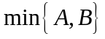 which means taking the minimum value of the set. The disjunction (OR) operator of A and B is defined as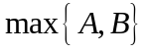. And the complement (NOT) operator is defined as  (or). Since Boolean logic is quite easy to learn, the learning curve for fuzzy logic is probably the same. Of course, there are differences between Boolean logic and fuzzy logic in that Boolean logic is bivalent (two value) whereas fuzzy logic is multivalent with the range of 0.0 to 1.0. Still, the concept of the three operators is similar if we restrict the values of the fuzzy logic to only 0 and 1.

Fuzzy logic is useful in many applications and it seems the most popular and the most well recognized of them all is the fuzzy subway control system in Sendai, Japan. Using fuzzy logic control, the train system operates automatically with only the conductor’s present as a safety precaution. Although, my project is not about train system, it goes to show how fuzzy logic can be implemented to efficiently run mass transit systems. For my project, I used an example called “Dinner for Two, from the Top” from Mathwork’s Matlab program to demonstrate the fuzzy logic in its simple to understand natural language program.
The general sequence of steps in designing fuzzy logic machine is known as fuzzificationrule evaluationdefuzzification. The first thing to do is to give know how much to tip in the tipping program. In this case, the example goes as follow:
“1. If the service is poor or the food is rancid, then tip is cheap.”
“2. If the service is good, then tip is average.”
“3. If the service is excellent or the food is delicious, then tip is generous.”

Here we see that there is not numerical value in the initial statement since this provides a better meaning from a human’s perspective. In other word, using words such as “poor”, “good”, and “excellent” make much more sense than would just giving numerical values.
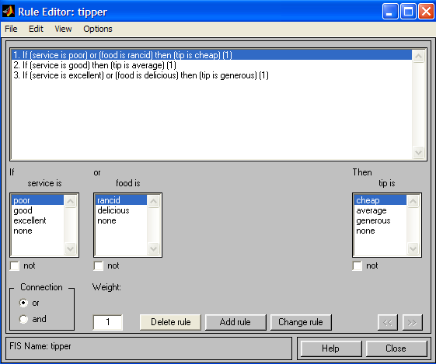
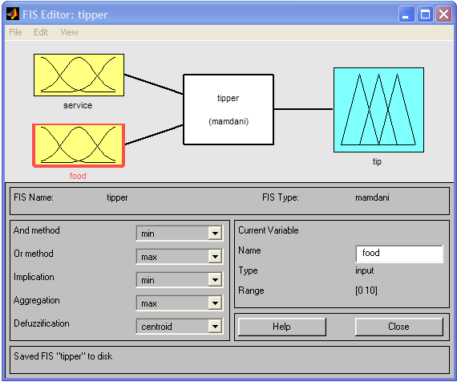
As you can see, this example has two input or memberships (service and food) and given the type of input, the “tipper” would output the amount (cheap, average, generous) to tip.
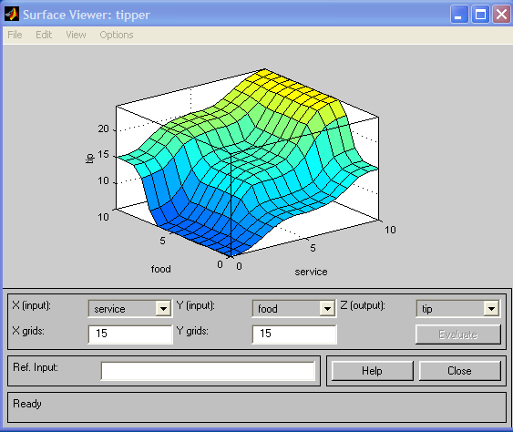

Although fuzzy logic is mostly used in control systems, I see a bright future for fuzzy logic in the artificial intelligence field because with fuzzy logic, we can program the computer to think more like human’s analog world instead of the computer’s digital binary world of 0s and 1s. To us human, nothing is certain but we are certain to a degree and so thanks to Dr. Zadeh’s fuzzy set theory, computers might eventually think like human. Of course, it is not certainly true but it is certainly true to a degree.

Bibliography:

FIDE (Fuzzy Inference Development Environment),
http://www.aptronix.com/fide/whatfuzzy.htm

Josh Hanz, Fuzzy Logic and Controls Annotated Bibliography + Position Paper: Sendai Subway, April 1999.
http://www.ecst.csuchico.edu/~hanzi/fuzzy/biblio.html

Mathworks - MatLAB, Learning Fuzzy Logic Toolbox,
http://www.mathworks.com/access/helpdesk/help/toolbox/fuzzy/fuzzy.shtml

Jeyakody Parthiban, Fuzzy Logic and Its Uses Article 1,
http://www.doc.ic.ac.uk/~nd/surprise_96/journal/vol1/jp6/article1.html

Jeyakody Parthiban, Fuzzy Logic and Its Uses Article 2,
http://www.doc.ic.ac.uk/~nd/surprise_96/journal/vol2/jp6/article2.html

Microsoft® Bookshelf® Computer and Internet Dictionary© 1997 Microsoft Corporation. All rights reserved. Portions, Microsoft Press® Computer Dictionary, Third Edition. Copyright © 1997 by Microsoft Press. All rights reserved.

