Michael Bissell
Artificial Intelligence
Spring 2016
Dr. Wang

Introduction

Included is a Jess-developed expert system with commands that define a population of trees and changes their locations in various Seattle parks according to specific states (weather, time, etc). Jess is based on the Rete Algorithm, a pattern matching algorithm for production rule systems, the latter of which are programs designed for a specific purpose and are usually the resulting product of becoming proficient with such an AI environment. The goal of expert systems of course, is to emulate the decision-making process that humans undergo.

Topic

City parks need trees. Would these places in fact, exist as parks without their existence? Because of this observation, a group of humans will generally transport trees and replant them on site. The city government, in this case Seattle, WA may hold a meeting to vote on what kinds of plants will make up the park. Local and foreign plants are considered There are, actually optimal conditions for transplanting trees.

For example, deciduous trees that lose their leaves during the fall season should be moved before the leaves fall in order to re-establish their root systems before a winter freeze or even during the freeze, when they are dormant. It is also generally too stressful for the plant to be moved during a springtime growth phase. As the reader may have guessed, an expert system developed by Jess, “treemovers.clp” will best prescribe which trees for humans to transport and at what time of year, while thinking about the weather.

Facts

Jess uses the assert statement to insert facts into its knowledge base. Here, we will define a template to structure the concept of a tree and assert various types of trees across several park systems. To begin, multislots can hold multiple strings. We’ll let the type of tree, and location be multislot. Here, we’ll add a placeholder to designate the leaf type, age, and leaf color.

(deftemplate tree
"A specific plant."
(multislot type)
(slot leaf)
(slot age (type INTEGER))
(multislot location)
(slot leafcolor (default green)))

Big Leaf Maples in Carkeek Park
(assert (tree (type bigleafmaple) (leaf broad) (age 300) (location Carkeek Park WA) ))

Evergreens on Tiger Mountain
(assert (tree (type evergreen) (leaf needle) (age 90)(location TigerMountain WA) ))

Red Alders in Discovery Park
(bind ?movingtree (assert (tree (type red alder) (leaf broadleaf) (age 20) (location Discovery Park WA) )))

Functions

Since the Red Alder in Discovery Park was bound to the tree to be moved, ?movigtree let’s go ahead and define the function movetree . This function will modify the location to Carkeek Park.

(deffunction movetree ()
(modify ?movingtree (location Carkeek Park WA)))

Modification for Tree Movers from JFrame Demo
;Modified from Basic JFrame demo
(deffunction create-frame ()
(bind ?*f* (new JFrame "Tree Movers Preliminary"))
(bind ?*c* (?*f* getContentPane))
(set ?*c* background (Color.green)))

The add widgets function will set the layout and form a Combination Box
(deffunction add-widgets ()
(?*c* add (new JLabel "This is: ") (BorderLayout.CENTER))
(bind ?*m* (new JComboBox))
(?*m* addItem "A Potential Forest")
(?*c* add ?*m* (BorderLayout.NORTH)))

Add Behaviors instructs how to close the window
(deffunction add-behaviours ()
(?*f* setDefaultCloseOperation (JFrame.EXIT_ON_CLOSE))

(?*m* addActionListener (implement ActionListener using
(lambda (?name ?event)
(printout t "You chose: " (get ?*m* selectedItem) crlf)))))

Show frame makes it visible
(deffunction show-frame ()
(?*f* pack)
(?*f* setVisible TRUE))

Rules

As mentioned previously, moving a tree at the wrong time can prove fatal for the plant. Let’s set up various rules for the program to follow; seasons. Obviously, we only would like to move the tree in the early fall or late winter.

; RULE relocate-tree
; IF
; The season is spring
; THEN
; Say that the best time to move
; is early fall or late winter

(deffacts initial-season
(season spring)
)

(create-frame)
(add-widgets)
(add-behaviours)
(show-frame)

(defrule relocate-tree
(season spring)
=>
(printout t "Early fall or late winter is best..")
)

Conclusions

Jess syntax can be easily learned and there are plenty of options to explore. In this project, experience was gained experimenting with an expert system development environment. An included example is called, “jframe.clp.” In it, imported libraries are declared and Java objects are bound to variables. It seems interesting and could be useful for our tree moving program by utilizing other Java objects, though requiring more overhead. It was still fun to add the ?movingtree item to the dropdown box:

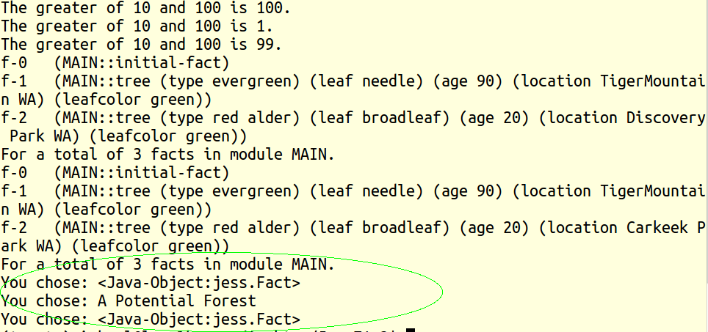

Lessons Learned

Seattle Parks and Recreation lists over 400 parks and 120 miles of walkable trails. While a certainly basic example program is described herein, the program developed in this project seems to venture into uncharted territory and may be extended, provided larger datasets and coding. Starting earlier on the development of this project would have been more prosperous, but the idea to apply an expert system to tree care occurred out-of-the-blue and only recently, towards the course’s end date.

