Noor Albarakati
CIS 2033 – Lab HW #2

M4.2. (20p)
- Binomial Distribution
A random variable X follows the binomial distribution with parameters n and p, X ~ Bin(n, p), when its probability mass function is given as:
$PMF= P\left(X=k\right)= \left({n \atop k}\right) p^{k} {(1-p)}^{n-k}$, for k={0, 1, 2, …, n} number of successes
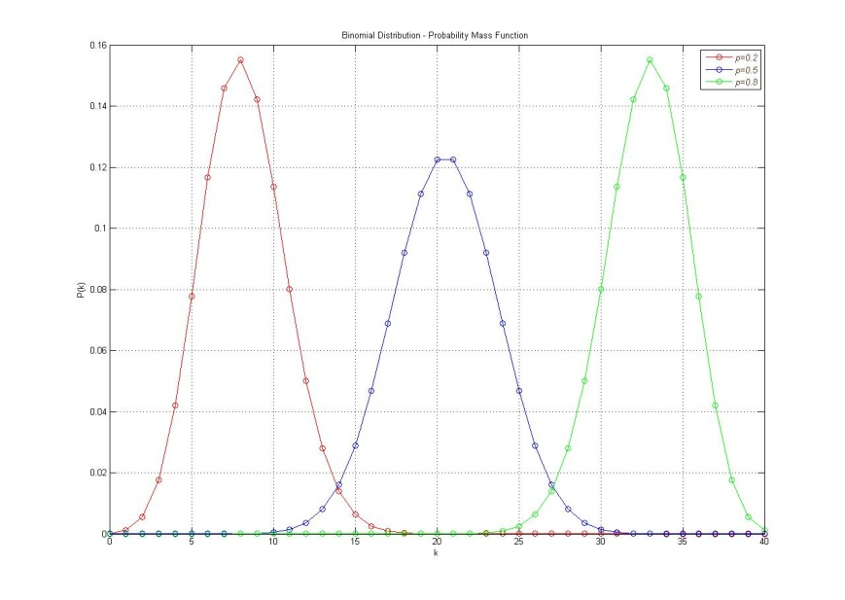

And when the cumulative distribution function of X ~ Bin(n, p) is given as:
$$CDF= F\left(k\right)=P\left(X≤k\right)= I_{1-p} \left(n-k, 1+k\right)=\left(n-k\right)\left({n \atop k}\right)\int_{0}^{1-p}{t^{n-k-1}}{\left(1-t\right)}^{k}dt$$
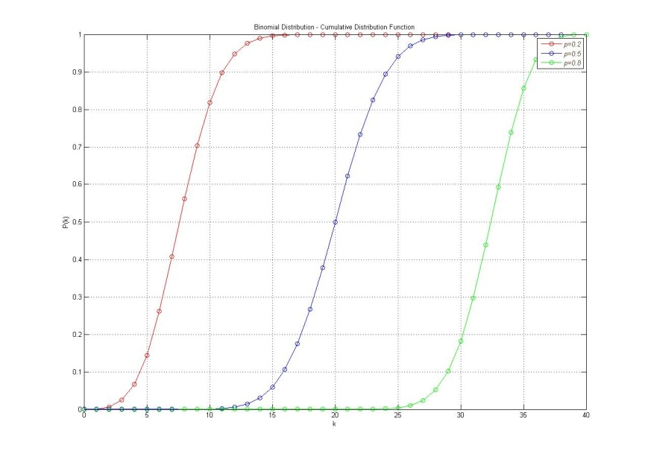
It seems when the p = 0.5, carve is setting in the mean of dataset. Once the value of p is increased, it will be shifted into right, and it will be to the left when p is decreased. Also, the peak of the plot is getting high.

- Geometric Distribution
A random variable X follows the geometric distribution with parameters p, X ~ Geo(p), when its probability mass function is given as:
$PMF=P_{X}\left(k\right)=P\left(X=k\right)={(1-p)}^{k-1} p$, for k=1, 2, …
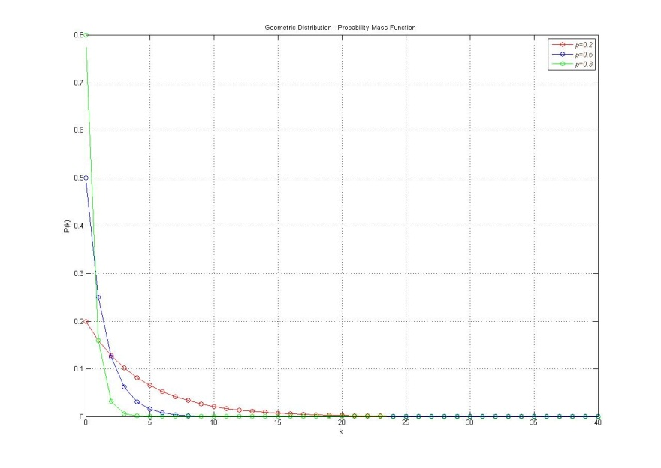

And when the cumulative distribution function of X ~ Geo(p) is given as:
$CDF= F\left(k\right)=P\left(X≤k\right)= 1-{(1-p)}^{k}$

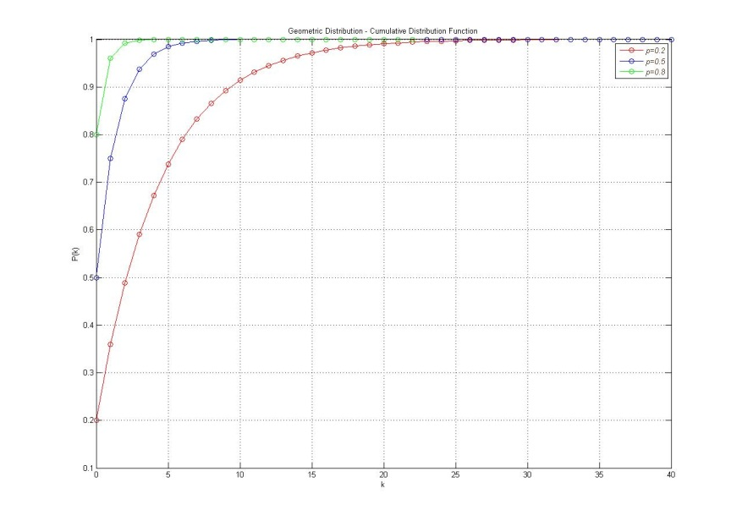
It seems when p is 0.5 and higher, the curve almost close to 1, and when p is small, it’s less in its probability.

