(10p, I have no idea what you are doing here?)

a) Plot the probability mass function and the cumulative distribution function of a binomial distribution for a few different values of the parameter p.
How does their shapes changes as the function of p?

p = 0.65; % Probability of success for each trial
n = 6; % Number of trials
k = 2:n; % Outcomes
m = binopdf(k,n,p); % Probability mass vector
bar(k,m) % Visualize the probability distribution in bar graphic
plot(k,m); % Visualize the probability distribution

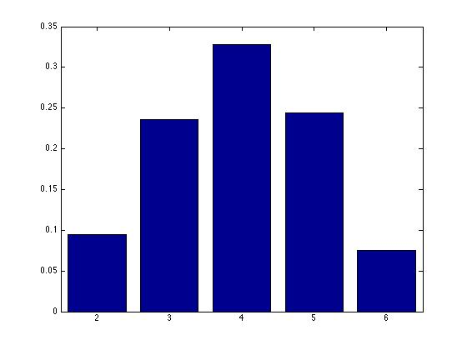
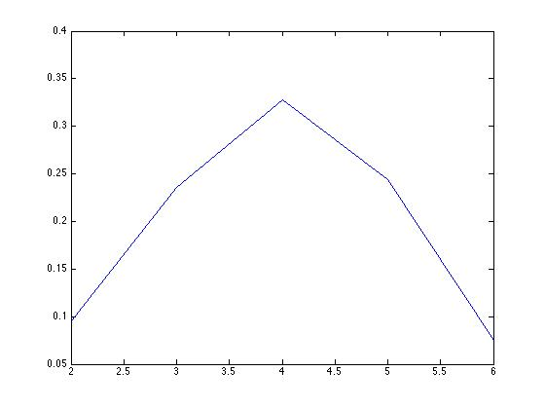
(b) Plot the probability mass function and the cumulative distribution function of a geometric distribution for a few different values of the parameter p.
How does their shapes changes as the function of p?

P = 0.5; % Probability of success for each trial
X= 0:25;
Y = geocdf(X,P); % Probability mass vector
bar(X,Y) % Visualize the probability distribution
plot(X,Y);

