Binomial PMF (5p, no discussion)
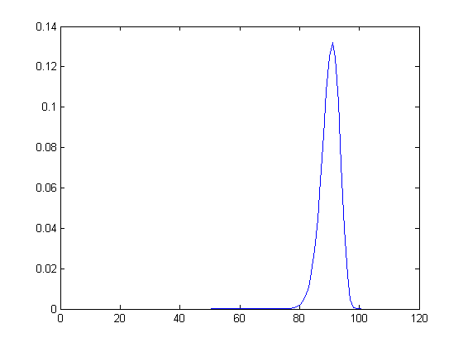
The probability raises sharply at 80 peaks at 90 and declines at 100. This is for when we have 25 sucesses in 100 attempts.
Binomial CDF
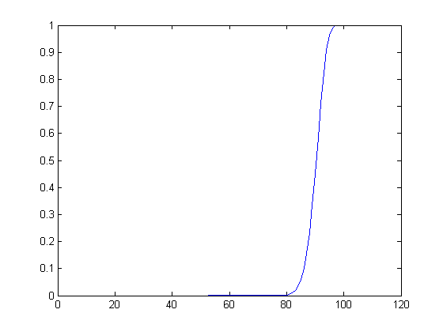
The probability raises sharply at 80 and climbs to 1 at very close to 100. This is for when we have 25 sucesses in 100 attempts.
Geometric PMF
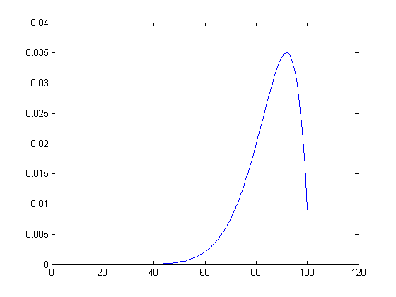
The probability rises exponentially at 60 and declines more rapidly at 90. For 10 trials at various probabilities.
Geometric CDF
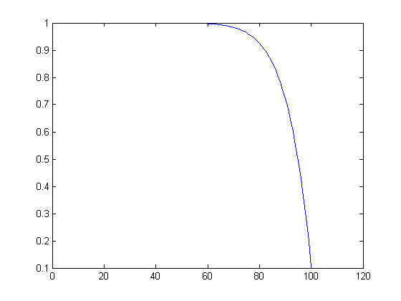
The probability declines rapidly at 80 and tails to 0. For 10 trials.

