Nouf Albarakati- M4.2 (20p)

- Probability mass function and cumulative distribution function of binomial distribution.

 | PMF | CDF
P=0.1 | 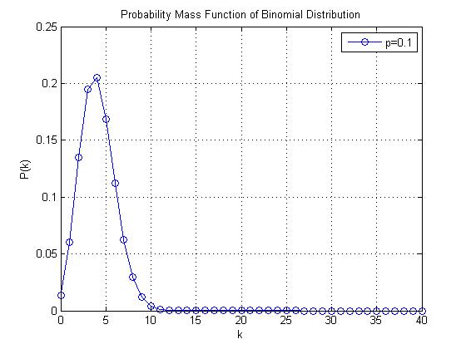 | 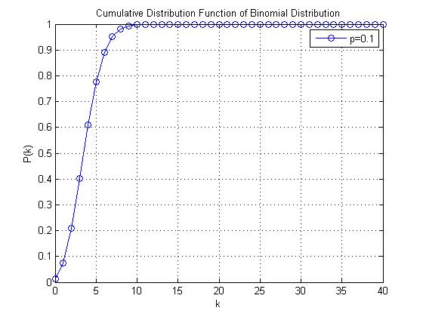
P=0.5 | 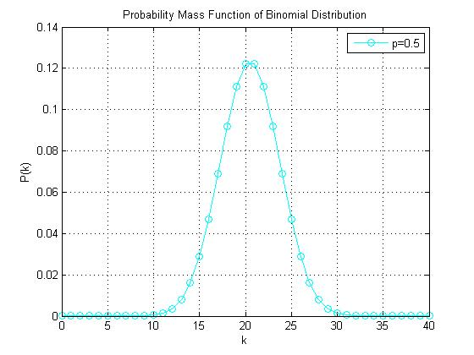 | 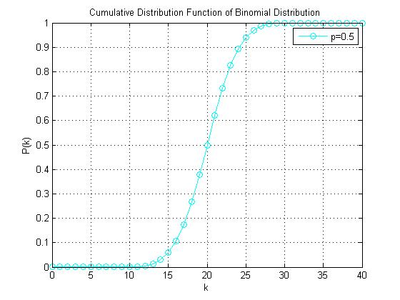
P=0.7 | 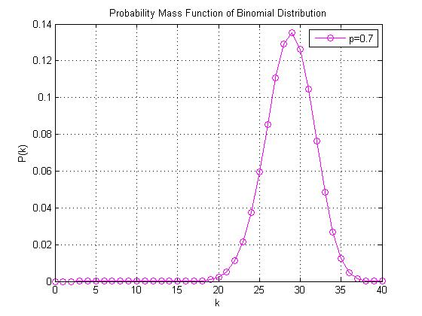 | 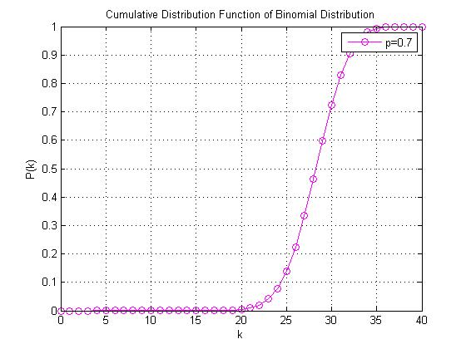
 | the PMF plot is shifting to the right as the p value increases. Also the peak of the plot is getting higher. For CDF, the plots is shifting to the right as much as the PMF does

- Probability mass function and cumulative distribution function of geometric distribution.
 | PMF | CDF
P=0.1 | 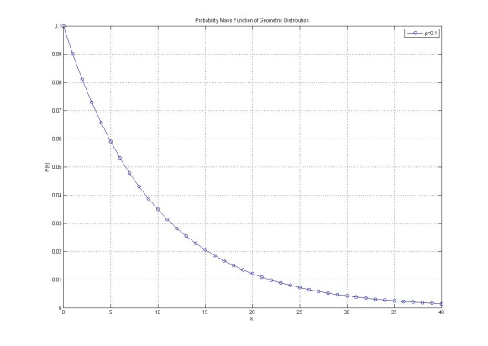 | 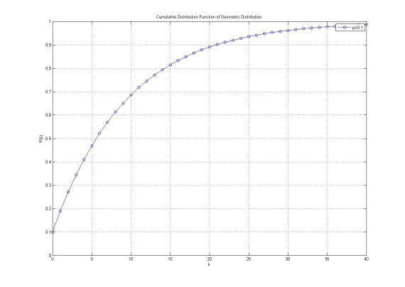
P=0.5 | 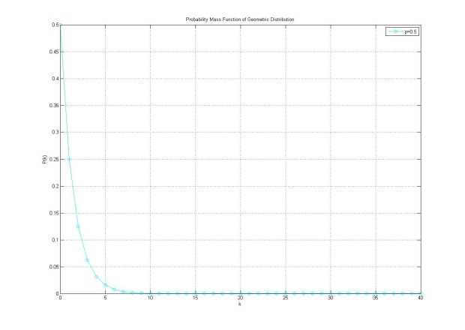 | 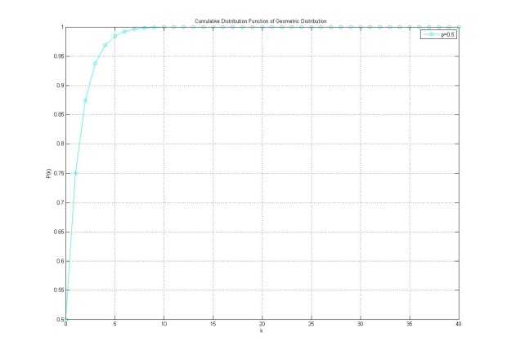
P=0.7 | 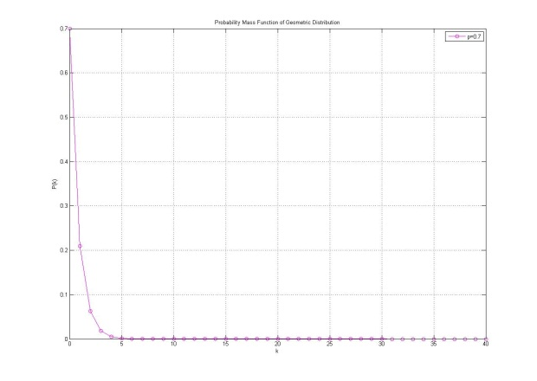 | 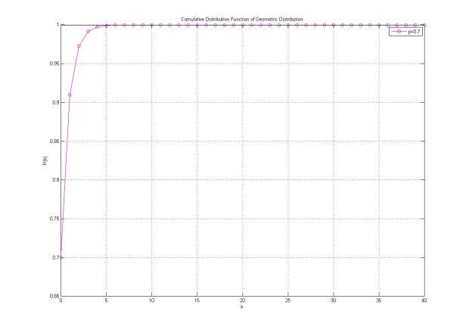
 | The PMF and CDF plots are a reflection to each other. The curves get sharp as the p value increases

