Matlab Assignment 2 4.2 Carl Kleinhans (20p)

- probability mass function of binomial distribution
x = 0:10;
n = 10;
p = .5;
y = binopdf(x,n,p);
plot(x,y,'+')
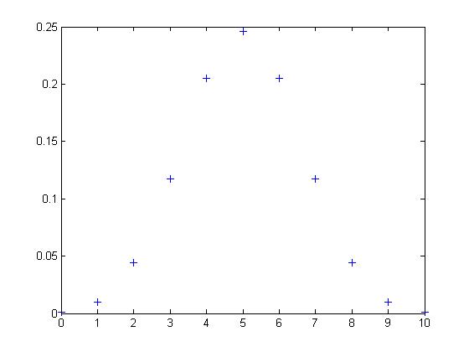
x = 0:10;
n = 10;
p = .7;
y = binopdf(x,n,p);
plot(x,y,'+')
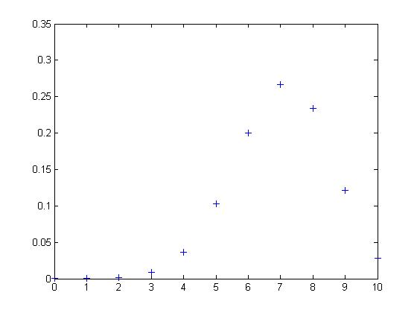
x = 0:10;
n = 10;
p = .3;
y = binopdf(x,n,p);
plot(x,y,'+')
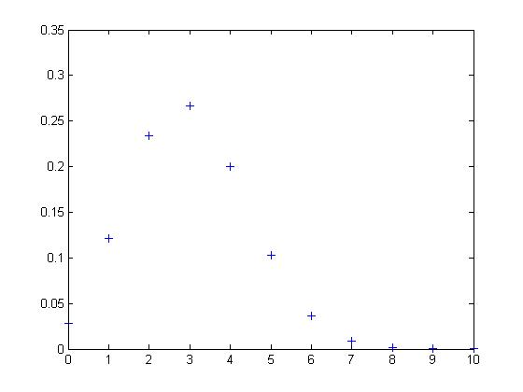
- cumulative distribution function of a binomial distribution
x = 0:10;
n = 10;
p = .5;
y = binocdf(x,n,p);
plot(x,y,'+')
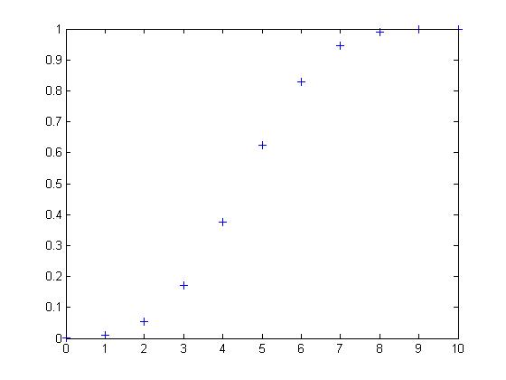
x = 0:10;
n = 10;
p = .7;
y = binocdf(x,n,p);
plot(x,y,'+')
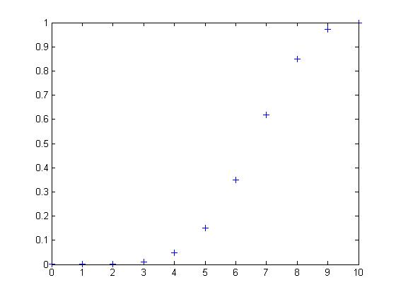
x = 0:10;
n = 10;
p = .3;
y = binocdf(x,n,p);
plot(x,y,'+')
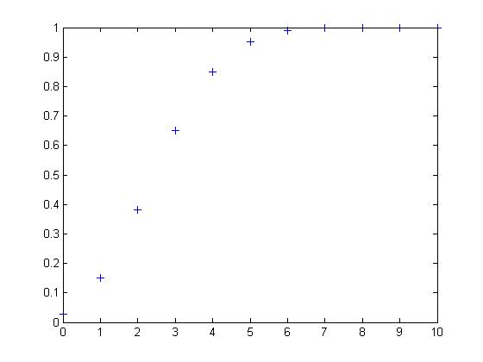
Conclusion: Changing P around just changes the local maximum of the graph. I am not really clear on the implications of why this is exciting or not.

b) Probability mass function of geometric distribution
x = 0:25;
p = 0.03;
y = geopdf(x,p);
stairs(x,y)
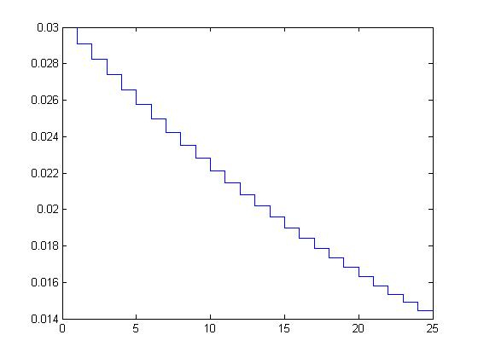
x = 0:25;
p = 0.15;
y = geopdf(x,p);
stairs(x,y)

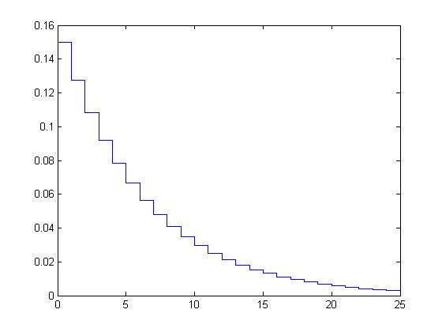

x = 0:25;
p = 0.25;
y = geopdf(x,p);
stairs(x,y)
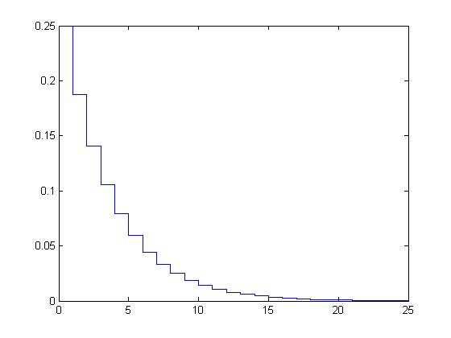

b) Cumulative distribution function of geometric distribution
x = 0:25;
p = 0.03;
y = geocdf(x,p);
stairs(x,y)
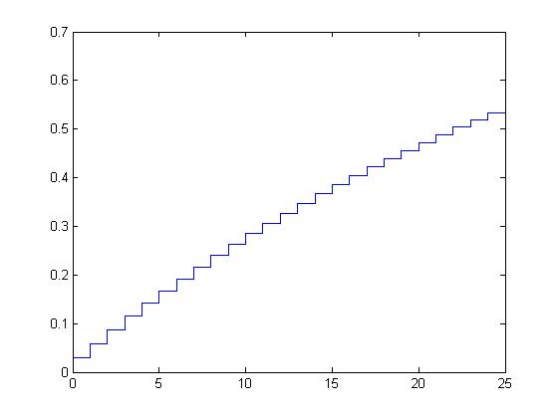
x = 0:25;

x = 0:25;
p = 0.15;
y = geocdf(x,p);
stairs(x,y)
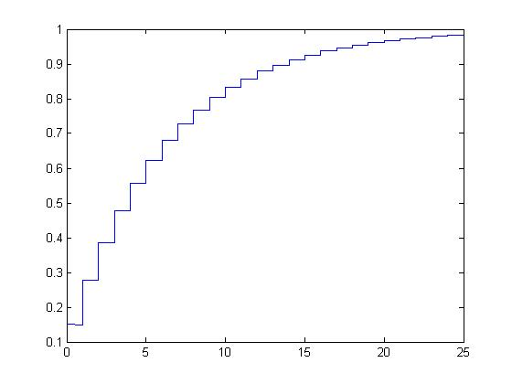
x = 0:25;
p = 0.25;
y = geocdf(x,p);
stairs(x,y)
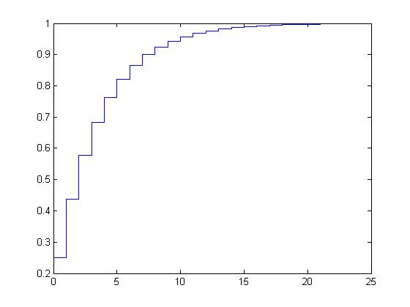
Conclusion: Changing P around, changes the smoothing of the curve. I am not really clear on the implications of why this is exciting or not.

