Figures of binomial distribution (20p)

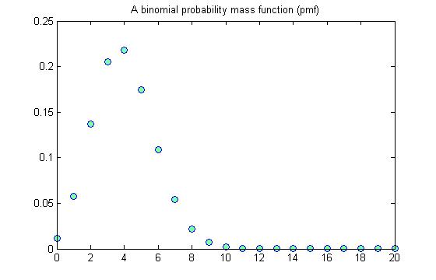

P=1/5

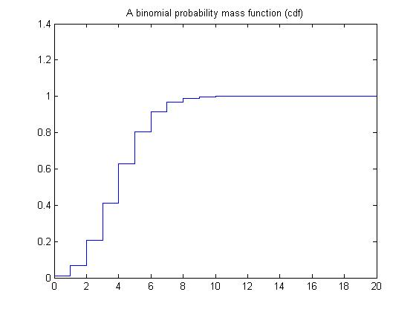

P=1/5

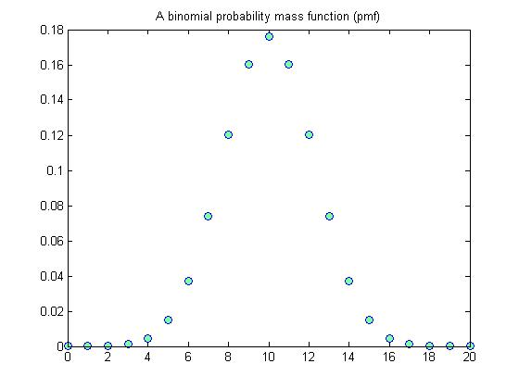

P=1/2

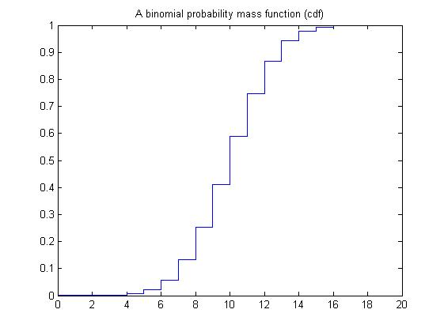

P=1/2

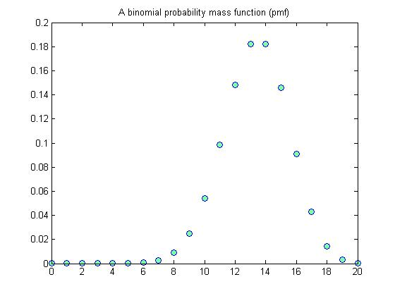

P=2/3

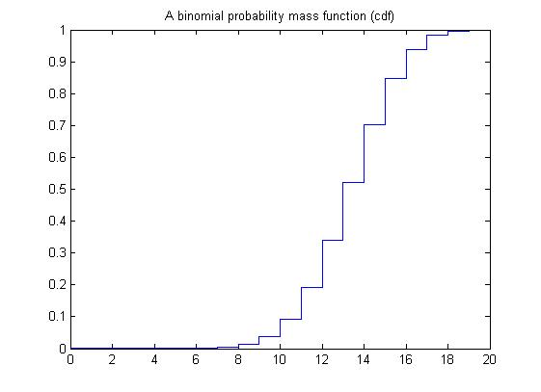

P=2/3

Figures of geometric distribution

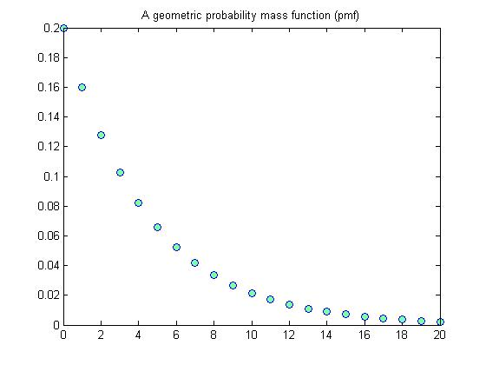

P=1/5

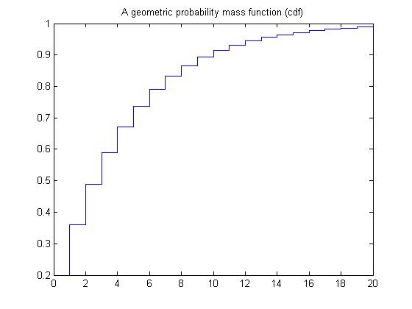

P=1/5

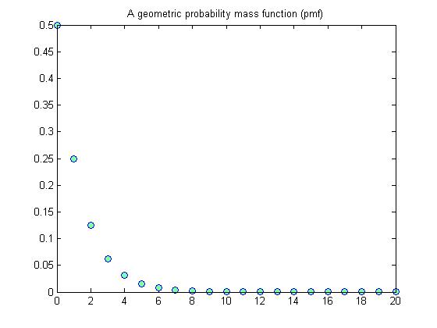

P=1/2

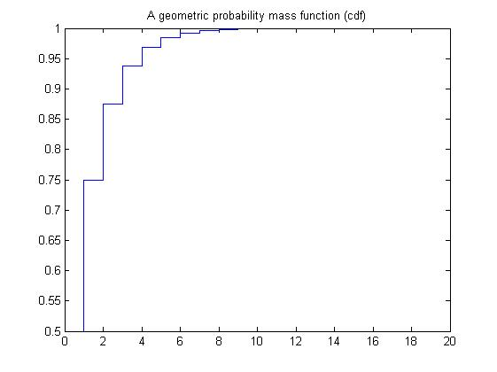

P=1/2

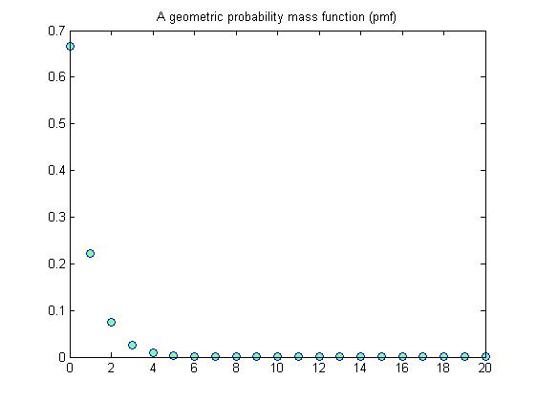

P=2/3

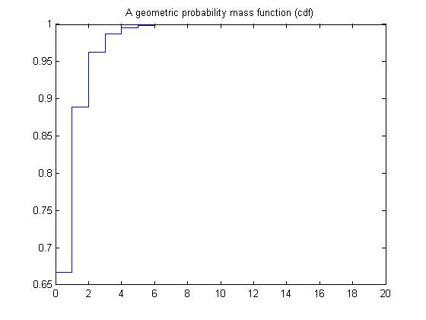

P=2/3

Through the binomial probability mass function graphs, the number of success experiments becomes bigger along with the value of probability becomes bigger.

However, the geometric probability mass function graphs show that the number of experiments becomes smaller along with the value of probability becomes bigger.