Darren Olah – M4.2 (20p)

% (a) Plot the probability mass function and the cumulative distribution function
% of a binomial distribution for a few different values of the parameter p.

% How does their shapes changes as the function of p?

For high probabilities, like .8, the PMF graph stays very low, appearing to hold around 0 until just under 25 trials in. Then the graph begins to rise, slowing down and curving back down at around 32 trials, finally resting at around 0 near 40 trials in. It appears like a thin parabola in the graph, although I don’t think parabola is quite the correct term for it.

The CDF for high-probability binomial functions looks somewhat like an “s.” It begins to rise up just as the ‘parabola’ of the PMF function begins to rise. It rises at an exponential rate, then, as the PMF graph begins to descend it slows down, logarithmically, coming to a rest very close to 1. 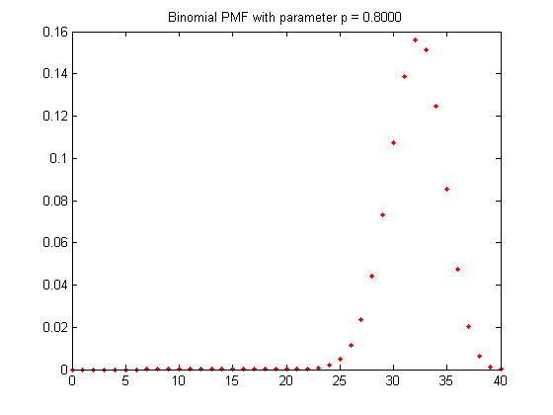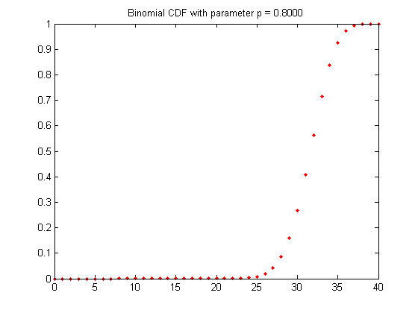

PMF graphs for low probabilities turn out to be similar, but their ‘parabola’ occurs earlier, with a peak at around the 9th trial for .2 probabilities. Their ‘parabola’ peaks close to .2 (or whatever low-probability you choose), meaning they are a lot less tall at their highest point than high-probability PMF graphs.

The CDF graph for low-probability CDF behaves similar to high-probability CDF graphs. It begins to rise exponentially as the ‘parabola’ occurs in its corresponding PMF graph. Then at the peak of the ‘parabola’ it continues increasing, but logarithmically. It settles very close to 1.

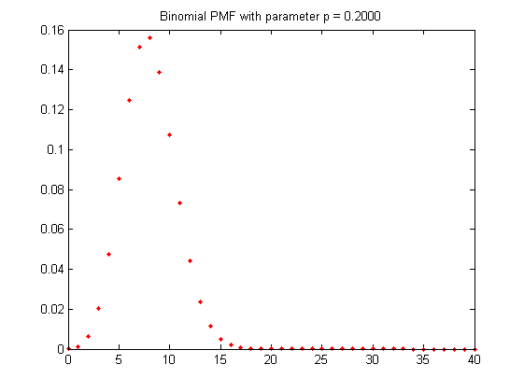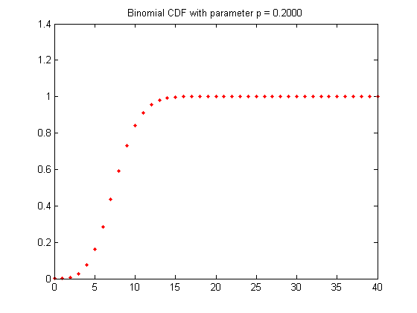

% (b) Plot the probability mass function and the cumulative distribution function
% of a geometric distribution for a few different values of the parameter p.

% How does their shapes changes as the function of p?

The PMF when there is a high probability, such as .9 or .8, starts very high, and drops rapidly within the first 2-3 trials. The graph becomes nearly flat at close to 0 after only a few trials. (For .9 there is nearly no perceptible movement after the third trial.)
The CDF is essentially the reverse for high probabilities. It quickly goes from 0 to extremely close to 1, within 2 or 3 trials.
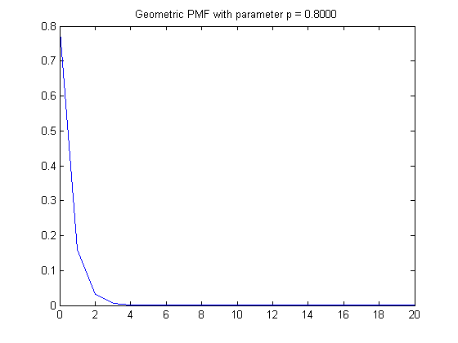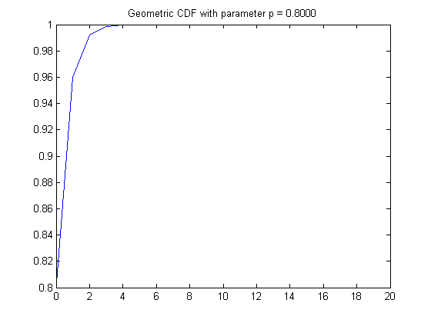

The graphs are a more gently sloping curve for geometric PDF’s of lower probabilities. The PDF of p = .3 drops from .3 down to near .2 after one trial. Then from .2 to around .15 after 2 trials. The curve begins to look flat close to 10 trials and above, but this happens much slower for low probabilities than high ones.
Once again the CDF of low probabilities is an opposite of the PMF. It gently slopes upwards from zero, beginning to flatten off above 10 trials.
