Matthew Murphy (20p)
Using the following MatLab code:
function binomial()
p = .75;
N = 10;
X = 1:N;

Y = binocdf(X, N, p);
figure;
plot(X, Y)
title(sprintf('Binmomail CDF p=%s', p));

Y = binopdf(X, N, p);
figure;
plot(X, Y)
title(sprintf('Binmomail PDF p=%s', p));
end

I produced the following graphs:
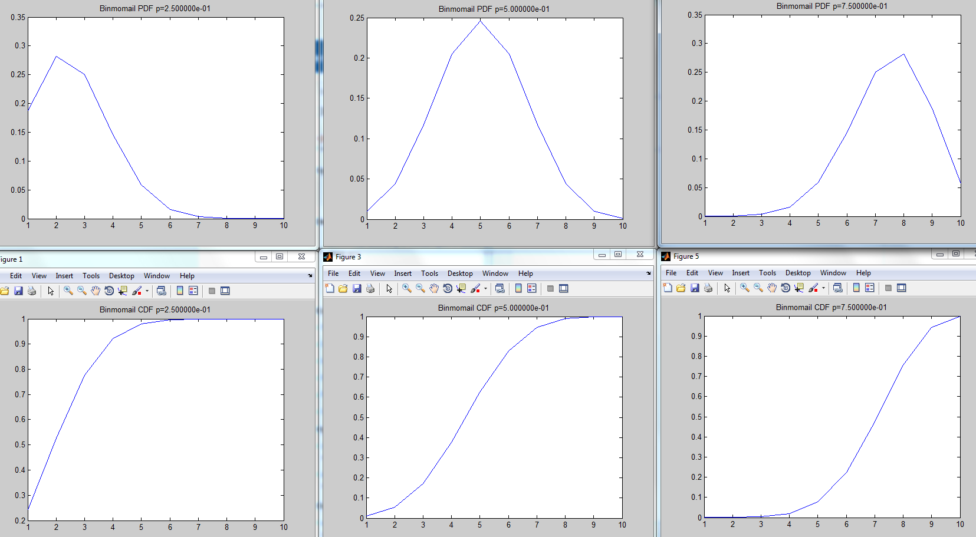
I discovered when p is increased the PDF peak moves to the right. The peak was above p.
The point of inflection moved right for the CDF. It was probably equal to p.

I used the following MatLab code:
function geometric
p = 0.75;
X = 0:10;

Y = geopdf(X, p);
figure;
plot(X, Y)
title(sprintf('Geometric PDF p=%s', p));

Y = geocdf(X, p);
figure;
plot(X, Y)
title(sprintf('Geometric CDF p=%s', p));
end

To generate the following graphs:
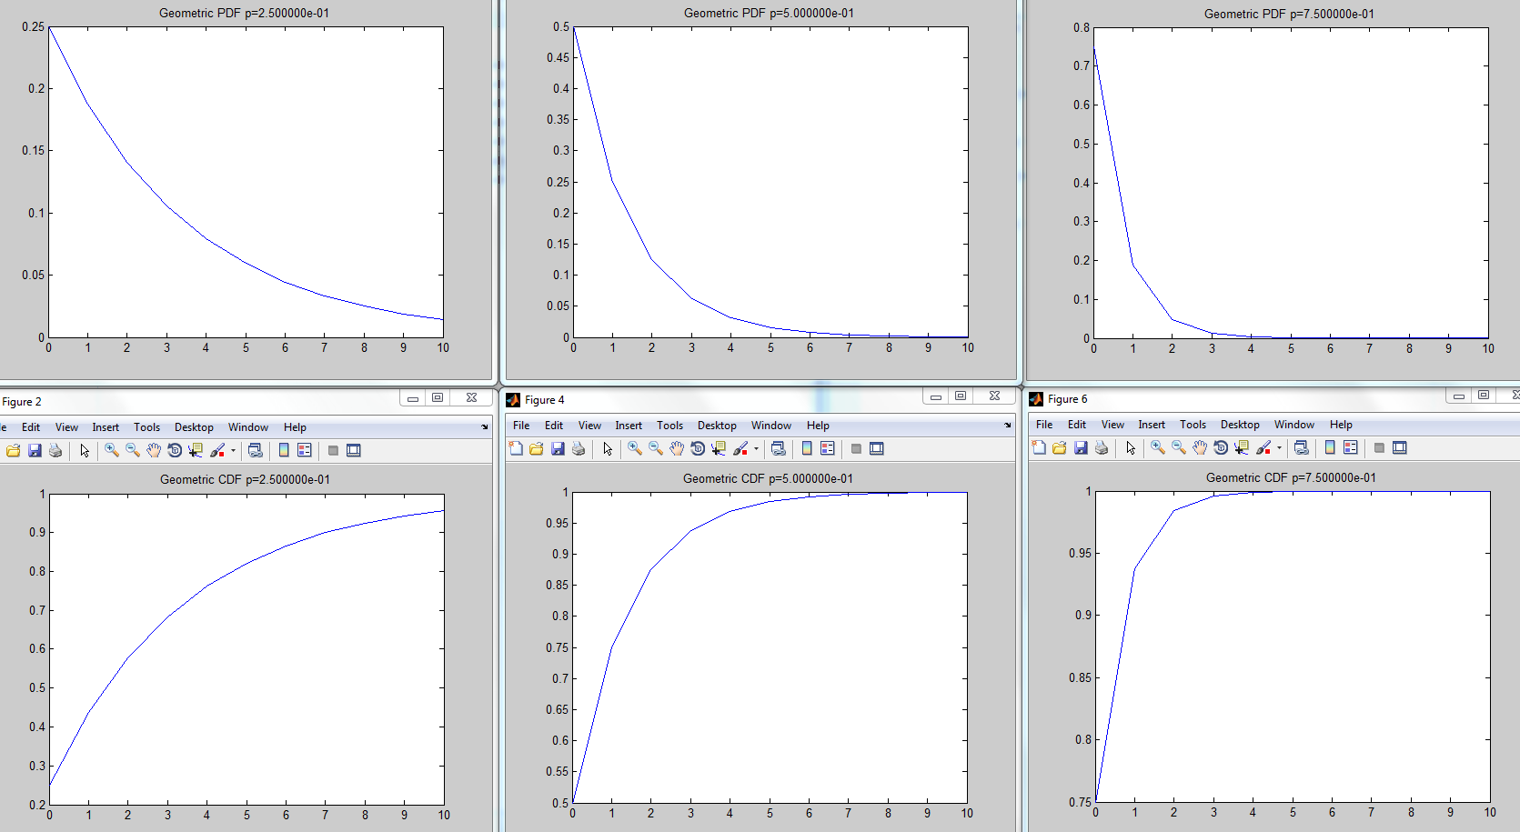
As p increased the PDF dropped faster. It looks like y(0)=p.
The CDF increased faster. It looks like y(0)=p.

