Michael Troy (20p)
Prob and Stat
Matlab 4.2
Part A) The Probability density function and the cumulative distribution function of a binomial distribution are shown below. For all values from 1-100 with the variable p set at .5

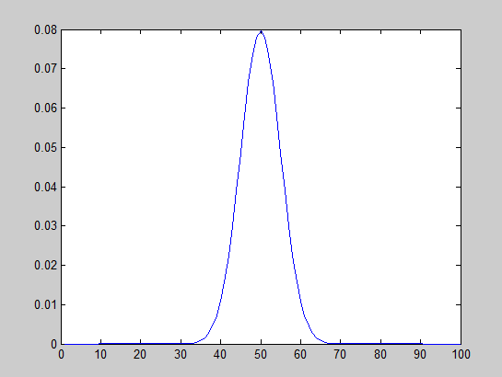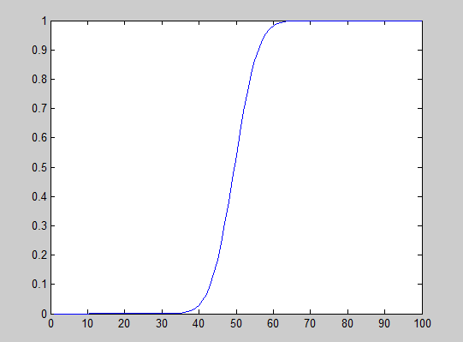
The variable p appears to designate the Local maximum of the density function. Since the cumulative function is the integral of the density function, then the sum of area under the curve is accumulated and maxes out at around the y value of 1.

Below is the same function with the value p set to .1 instead of .5
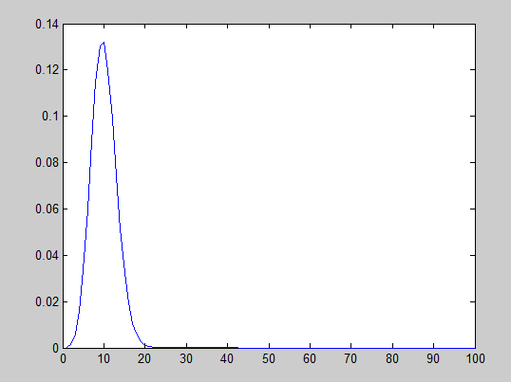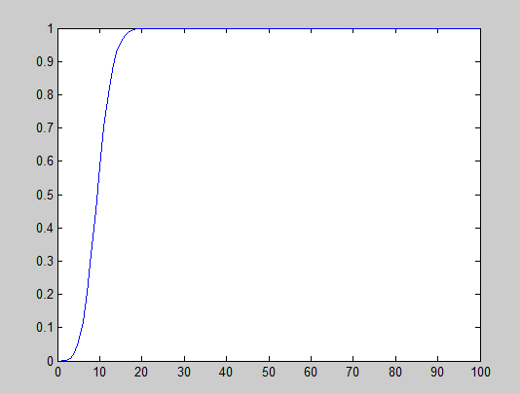
As you can see the function is now centered around the value 10 instead of 50. This means that if we set p as .9 then the local maximum should relocate to around 90 as shown in the next set of pictures.
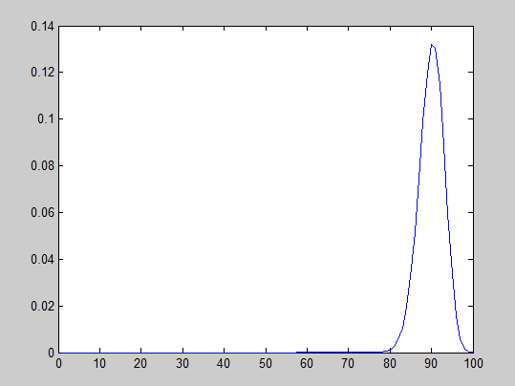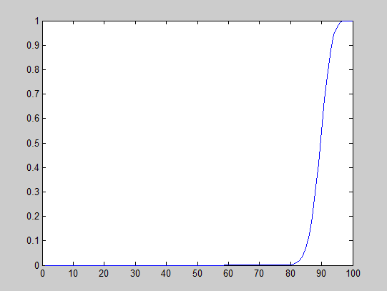

Part B) The next two figures show the probability density function and the cumulative distribution function of a geometric distribution. For all values from 1-10 with the variable p set at .5
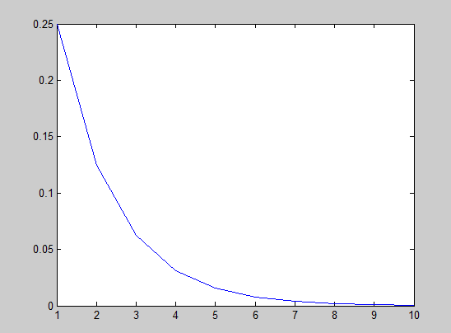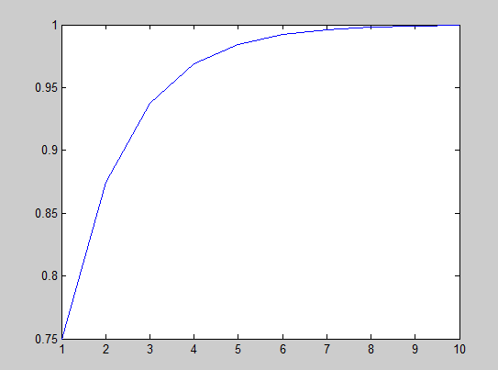
The Value P appears to designate the arc in the curve. In the next two pictures are the same function but with variable p set to .1
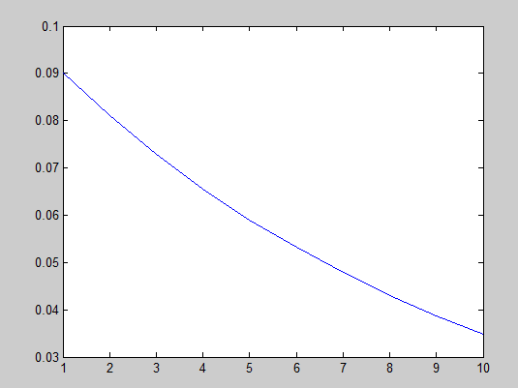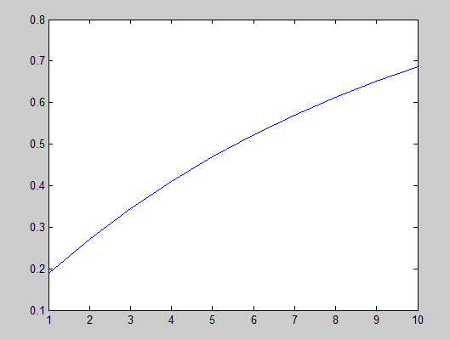
As you can see, the curve is much shallower, however it is also more smooth. This would allow us to lead to the assumption that increase the value p, would create a much more deep curve while at the same time making it much less smooth.

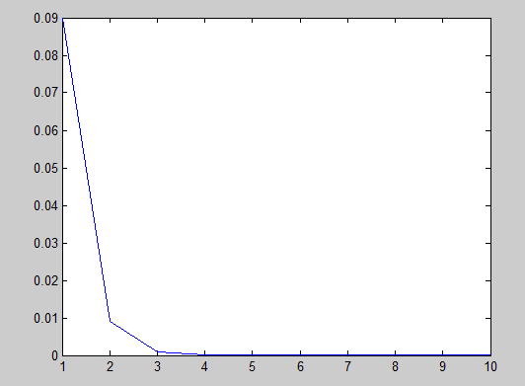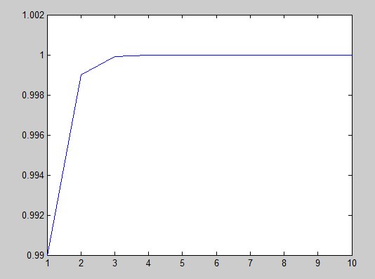
As predicted before the graphs have much deeper and rougher appearance.

