Akash Patel (7pt, pmf and its CDF cannot be negative)
A)
Graph 1:
p= 0.5
Probabliity Mass Function
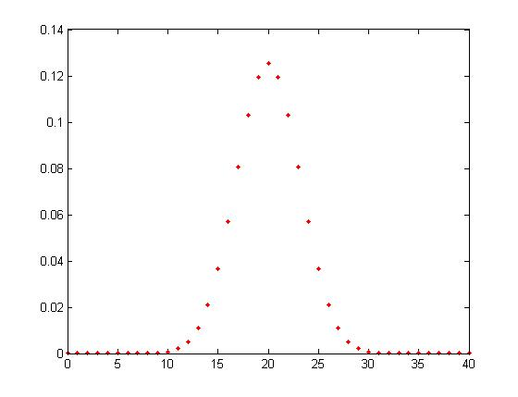

Cumulative Distribution Function
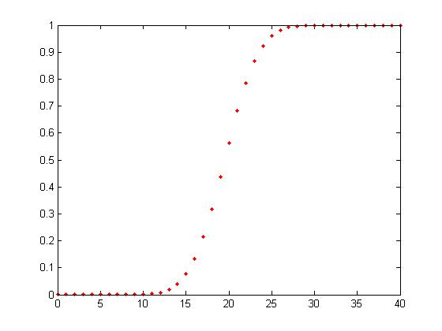

Graph 2:
p= 0.8
Probabliity Mass Function

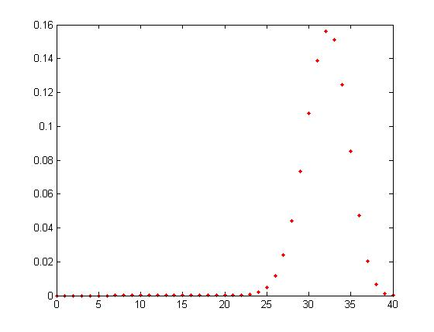
Cumulative Distribution Function
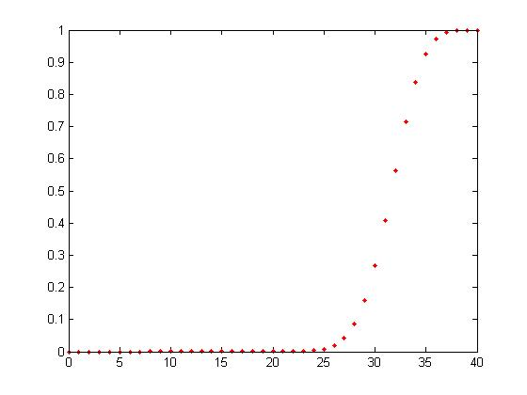

Graph 3:
P = .3
Probabliity Mass Function

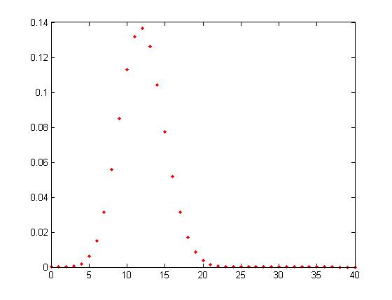
Cumulative Distribution Function
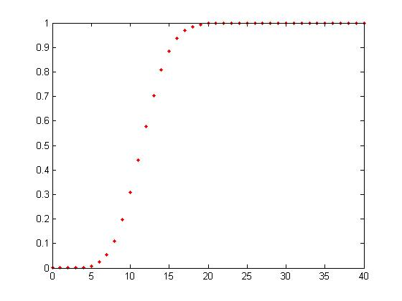

Graph 4
p = 2
Probabliity Mass Function

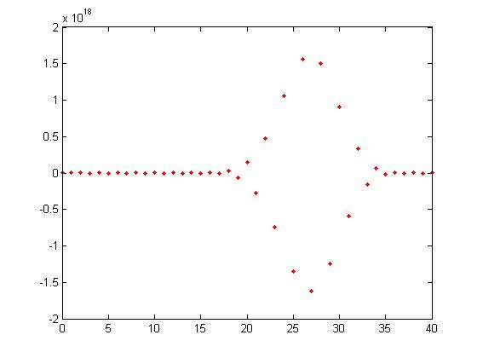

Cumulative Distribution Function
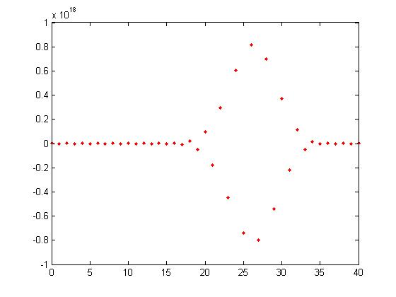

Graph 5:
P = -3
Probabliity Mass Function

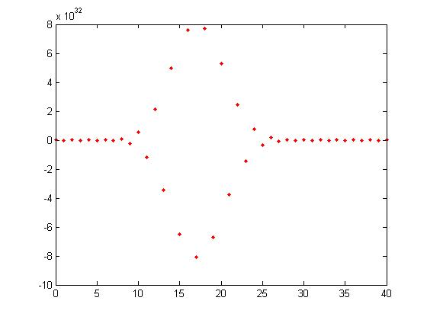

Cumulative Distribution Function
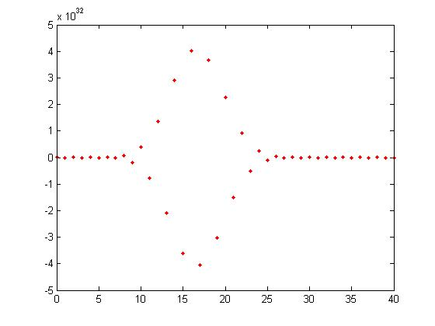
From these examples, I can conclude that when p is increased the graph tends to shift to the right. Also the higher it goes it tends to start making a diamon shape graph. When p is decreased the the graph tends to shift to the left. The lower the number gets it also makes a diamond shape graph but tends to be stretched more vertically. The same properties were happening with the cumulative distribution function. The graphs shifted to the right when p was increased and shifted to left when p decreased.

B)

Graph 1
p=1
Probabliity Mass Function
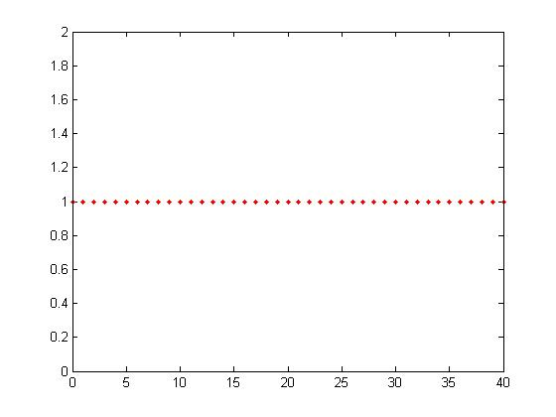
Cumulative Distribution Function
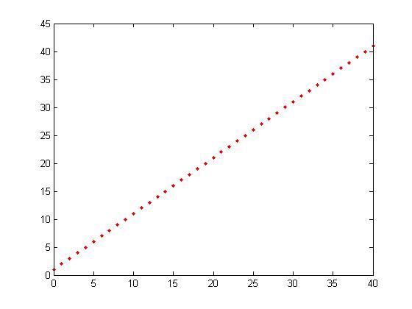

Graph 2
P=.7
Probabliity Mass Function
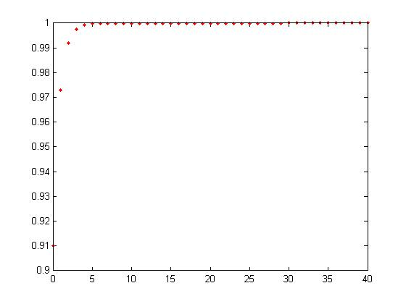

Cumulative Distribution Function
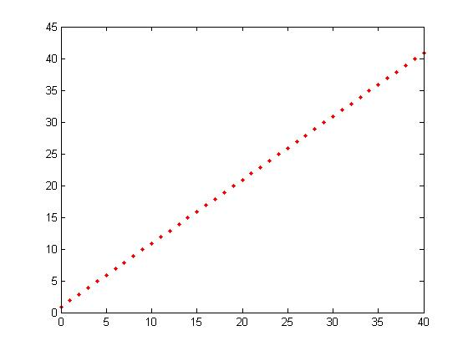

Graph 3
P=.4
Probabliity Mass Function
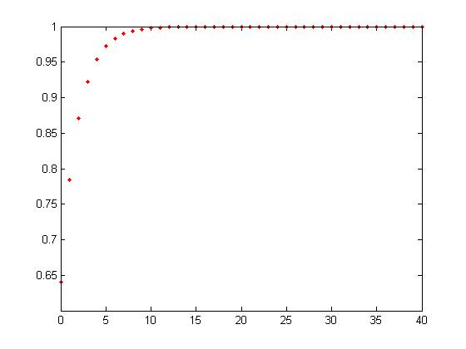

Cumulative Distribution Function
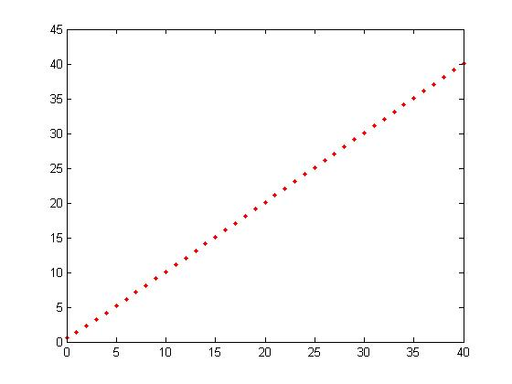
Graph 4:
p=.1
Probabliity Mass Function
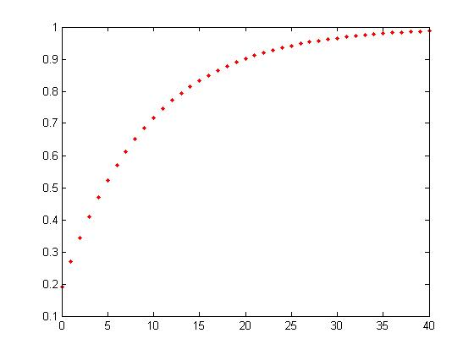

Cumulative Distribution Function
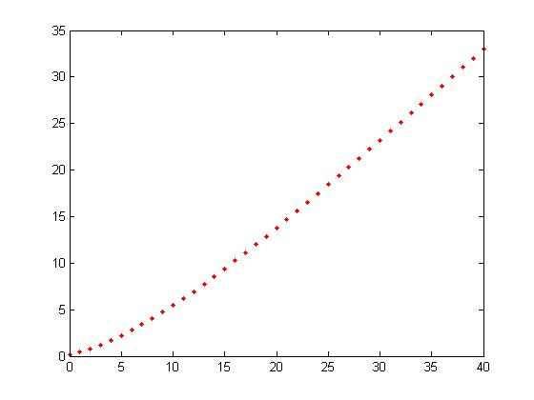

In this geometric distribution you can see that for the probability mass function, when p was 1 it was a straight line and once p was decreased it started to form a litter arc starting from the top right. The lower the p got the more angle the arch started to get. For the cumulative distribution, the graph stayed the same all through the higher range of p until it reached p=.1. That is when it start to bend down in its arch cause a slightly inward angle

