Vatche Kaprielian (2p for submitting the solution, but your solution is wrong)
CIS 2033
- a. This graph shows the probability mass function of a Binomial Distribution with different values of parameter p. no this graph is one value of p!
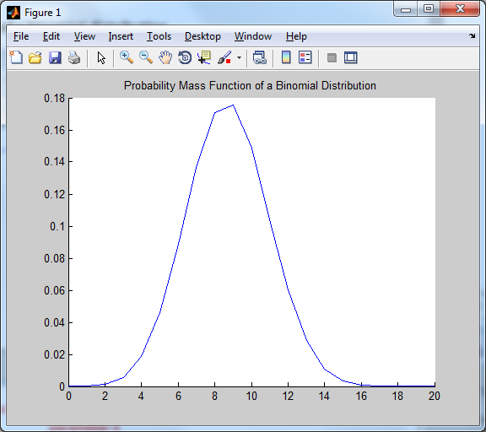

b. This graph shows the Cumulative Distribution Function of a Binomial Distribution with different values of parameter p. no this graph is one value of p!
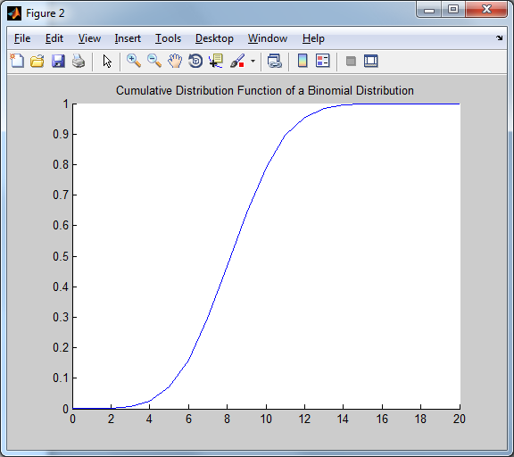

- a. This is a graph of the probability mass function of a Geometric distribution for different values of parameter p where p is 0.25 no this graph is one value of p!
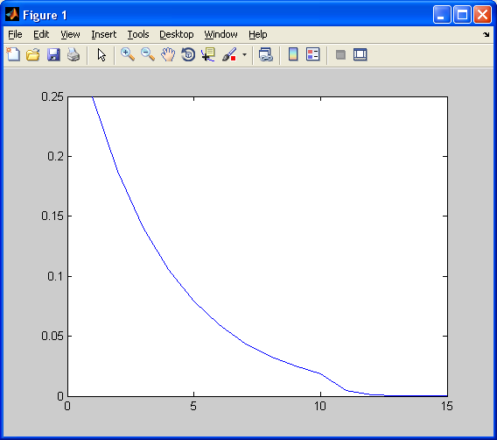

b) This is a graph of the cumulative distribution function of a geometric distribution for different values of parameter p where p = 0.25 no this graph is one value of p!
