Homework one based on Exercise 3.3.
Consider the problem of finding a path in the grid shown in Figure 3.13 from the position s to the position g. A piece can move on the grid horizontally and vertically, one square at a time. No step may be made into a forbidden shaded area.

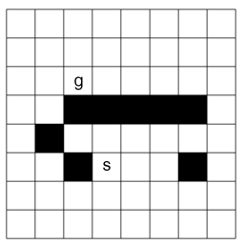
Figure 3.13: A grid-searching problem

- On the grid shown in Figure 3.13, number the nodes expanded (in order) for the A* search from s to g, given that the order of the operators is up, left, right, then down. Thus, each edge has length of 1, which is the length of the side of each grid square, i.e., if a path has 5 edges, its actual cost is 5. h(n) is the straight line (Euclidean) distance from node n to g. Stop when the node g is reached.
- Propose your own modification of A* that will reduce the number of nodes expanded before the goal node g is reached. Describe its properties. You must answer the following two questions: (1) is the first path found to g the shortest path?; (2) is your algorithm guaranteed to find a path to g?

