Image Retrieval using Edge Histograms

Tianyang Ma

By partition the image into several tiles, and compute the histogram by counting the pixels number of edge images for each tile, and use different similarity measure to calculate the distance, we implement an image retrieval system.
In the paper “EMD-L1: An Efficient and Robust Algorithm for Comparing Histogram-Based Descriptors ” published on ECCV 2006 by Prof. Haibin Ling, several histogram similarity calculation methods are discussed. For image retrieval, most used methods are norm p , ${ χ}^{2}$ , Kullback-Leibler Divergence, Earth mover's distance (EMD). In our system, all these histogram measure methods are tried, and performances are compared.
Since our descriptor is simply count the edge pixels number in a tile. The descriptor is apparently not quite discriminative. Also, when we only statistically calculate the histogram, the spatial information is lost, therefore, the feature could not effectively describe the content of the images. No matter what histogram measure methods we use, we could definitely be unable to get a very good performance.
Suppose number of class is m ,and we carry on a top-k query, then

$$Hit rate=\frac{Correct query result number}{m*k}$$

Measure | Class 1 | Class 2 | Class 3 | Class 4 | Class 5 | Sum | Hit rate
Lp (p=3) | 8 | 14 | 9 | 5 | 9 | 45 | 30%
$${ χ}^{2}$$ | 6 | 10 | 11 | 5 | 6 | 38 | 25.3%
EMD | 6 | 5 | 9 | 4 | 3 | 27 | 18%
Fomula 11 | 5 | 1 | 6 | 8 | 7 | 27 | 18%
Cosine | 6 | 3 | 4 | 4 | 4 | 21 | 14%
KL_divergence | 5 | 3 | 4 | 5 | 4 | 21 | 14%
Random guess | 3 | 6 | 3 | 3 | 4 | 19 | 12.7%
Note: Random guess is gotten by simulation , not theoretically proved.
According to the results form, we could conclude that for our edge histogram, the best similarity measure is Lp (when p=3).
However, even with the most effective histogram similarity measure, the system could only achieve a 30% hit rate. As mentioned above, our descriptor is simple, and without any spatial information, this results could be acceptable.

Reference:
[1] EMD-L1: An Efficient and Robust Algorithm for Comparing Histogram-Based Descriptors
H. Ling and K. Okada European Conference on Computer Vision (ECCV), LNCS 3953, III:330-343, 2006.
Appendix:
Parameter setting:
Tile size is 5*5
Histogram has 5 bins.
Threshold for canny edge detector is 0.5, while sigma for Gaussian filter is 1 .
Several query examples:
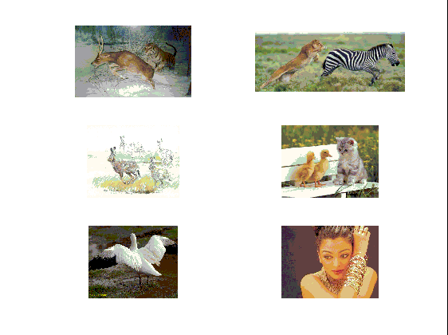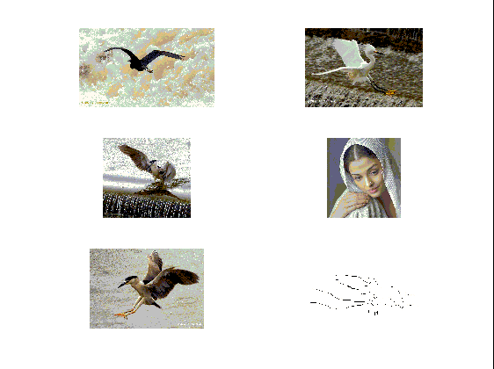

http://homepages.inf.ed.ac.uk/rbf/CVonline/LOCAL_COPIES/WAHL1/node5.html

