Assignment 1: Maze3D

Overview
Welcome to JMonkey and the beauty of 3D worlds. In this assignment, you will visualize a 2D maze in 3D. The assignment’s purpose is to introduce you to JMonkey, and to deal with geometries and their translations. What you will create looks like this:
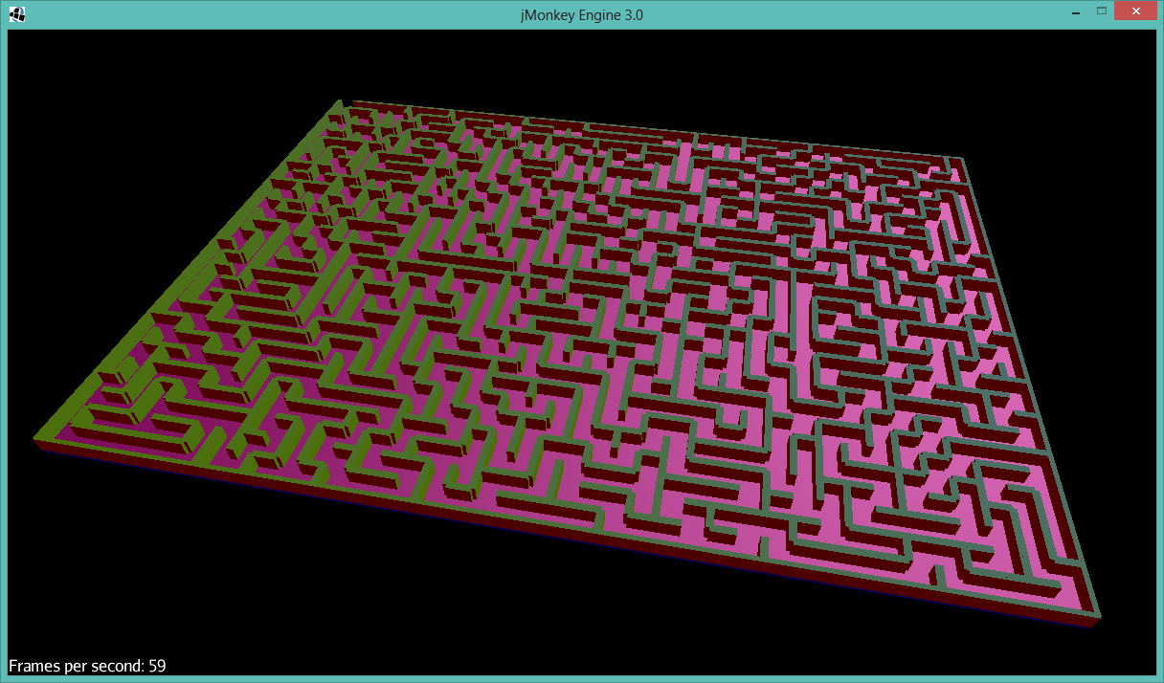
…not bad for a first assignment!

As usual, don’t panic (yet). You will not have to create the maze, you will be given a maze-creator class. This class creates (and optionally visualizes in 2D) a maze like this:
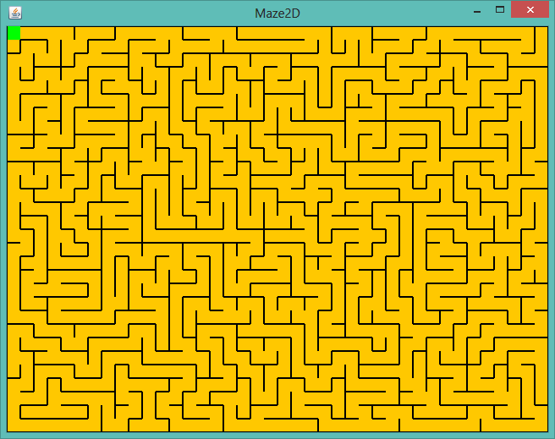
“That’s so 2168”, I hear you say, and rightfully so! The 2D maze comes from a 2168 assignment, which some of you might remember (you can look it up under https://sites.google.com/a/temple.edu/cis-2168-fall-2013/assignments). Nevertheless, it creates a nice maze, with accessibility to the maze data.

The JMonkey Project
The assignment starts with a JMonkey project already prepared for you. The project includes the Maze class, and a Main class which defines JMonkey Materials, sets the lighting etc. You are left with the remaining tasks to build the 3D maze from 2D data. This includes in particular, setting the JMonkey Geometries, and setting translations.
Here is a code snippet of the Main class:
public void simpleInitApp() {
initGui();
initMaterial();
initLightandShadow();
initCam();
//
buildMaze(40, 30);
}

The methods initXXXX() are already implemented. Your task is to implement the “buildMaze()” method. The method must create all Geometries that are necessary, and add them to the rootNode.
Important:
- Since the maze consists of repeating building blocks, the cells, with similar character, it makes absolute sense to create a class “MazeCell”, which extends “Node”. In fact, this is so straightforward, that I URGE YOU to create such a class! Building the maze then simplifies to a nested loop which adds MazeCells (i.e. Nodes) to the rootNode.
- Since this is about game programming, it also is not only about making thinks work, but optimizing for performance. The maze is constructed in a way, that, whenever a cell has e.g. a north wall, then its northern neighbor has a south wall (same for south, east, and west; see the Maze class explanation below). Hence, when you are constructing a cell in your MazeCell class, you only have to check for 2 walls, not for 4 (e.g. check for north and west, and add one east and south boundary for the entire maze after constructing the cells). This more or less doubles the performance!
- Be aware how many objects you create. For each MazeCell, you will create Geometry objects from a Mesh (here: Box) object for the walls. If you declare the Meshes static, there will be only a single instance, which is advisable. This means, every MazeCell is one object, each containing a different Geometry, but at least the basic building blocks, the Mesh object, is not duplicated all over. (This makes only sense if, in the Geometry, the Mesh is not cloned, but only stored as a reference. I did not look into the JMonkey source how it operates.

How to use the Maze class
The maze consists of single cells, stored in a 2D array (in the figure above: 30 rows, 40 columns). You don't need to care about the technical details, all you need to know is that each cell can be bounded by walls to the north, south, east, and west.

Not important for this assignment, but just as a note: each maze is created with a single, unique way out, which implies that there are no loops in any path. Also, from any point in the maze, there exists a path to the exit (which is always in the upper left corner ((row,col) = (0,0)).

The following figure shows a magnified part of the maze, to illustrate the cells and walls:

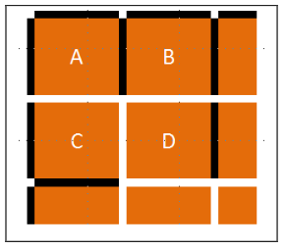 | Example:  - cell A has walls: N, E, W  - cell B has walls: N, E, W  - cell C has walls: W, S  - cell D has walls: E

You have access to the every single cell of the maze, and the cell-wall configuration, using the methods (in class Maze):

boolean hasNorthWall(int row, int column)
boolean hasSouthWall(int row, int column)
boolean hasEastWall(int row, int column)
boolean hasWestWall(int row, int column)

Please be aware that these methods take rows and columns, not xand y!

Class Maze API:

Constructor: Maze(int rows, int columns, boolean display)
Generates a maze of size rows x columns. A typical size would be 60x80. Bigger values tend to be critical. If display == true, the 2D maze is displayed in an extra window.

public boolean hasNorthWall(int row, int col)
returns true if cell(row,col) is bounded by a wall at its north side.
(equivalent: South, East, West)

public boolean isExit(int row, int col)
returns true if the cell row,col is the exit.

Bonus Points
- 1 point for textured materials: brick walls and dirt floor
- 1 point for camera flying (circling) over the maze
- additional points for more (implemented) ideas

Remarks:
- In a professional setting, you would be given the maze class in a package, without source code. Here, I preferred to include it into the project source, so you can have a look at the generator routine, if you want to.
- With systems of the complexity of JMonkey, it is normal not to understand every detail in depth. For example, the lights and materials, which I predefined for you, will be handled in class later this semester. Just use them as they are.

Btw. if you add shadows, it looks like the picture below. This also decreases the performance by a factor of 10! But it looks nice.
